**Mini-Project Report on**

PORJECT TITLE

**Submitted as fulfilment of the requirements for the award of the degree of**

**Bachelor of Technology in**

**Computer Science and Engineering**

**by**

**Akshay Srivastava – 1809710012**

**Under the Supervision of**

**Mr. T. Akilan**

**Mr. Mayank Dixit**



**Galgotias College of Engineering & Technology**

**Greater Noida, Uttar Pradesh**

**India-201306**

**Affiliated to**



**Dr. A.P.J. Abdul Kalam Technical University**

**Lucknow, Uttar Pradesh,**

**India-226031**

**May, 2020**

## **ABSTRACT**

**Python** is an interpreted,high-level and general purpose programming language. Python's design philosophy emphasizes code readability with its notable use of significant whitespace. Its language constructs and object-oriented approach aim to help programmers write clear, logical code for small and large-scale projects

The pygame library is an open-source module for the Python programming language specifically intended to help the user make games and other multimedia applications. Built on top of the highly portable SDL (Simple Direct Media Layer) development library , pygame can run across many platforms and operating systems.

By using the pygame module, user can control the logic and graphics of your games without worrying about the backend complexities required for working with video and audio.

**TABLE OF CONTENT**

|  |  |
| --- | --- |
| **Title** | **Page No.** |
| ABSTRACT | i |
| TABLE OF CONTENT | ii |

CHAPTER 1: INTRODUCTION 1

|  |  |
| --- | --- |
| CHAPTER 2: LITERATURE REVIEW | 3 |
| CHAPTER 3: PROBLEM FORMULATION  CHAPTER 4: SYSTEM DESIGN | 6 |
| CHAPTER 6: IMPLEMENTATION | 14 |
| CHAPTER 7: RESULT ANALYSIS | 19 |
| CHAPTER 8: CONCLUSION, LIMITATION AND FUTURE SCOPE | 21 |

**CHAPTER 1**

**INTRODUCTION**

**Text Adventure Game:**

**Castle Dungeons : An Interactive Story Game**

The meta-plot begins with the

anticipation stage , in which the hero is called to the adventure to come. This is followed by a dream stage , in which the adventure begins, the hero has some success, and has an illusion of invincibility. However, this is then followed by a frustration stage , in which the hero has his ﬁrst confrontation with the enemy, and the illusion of invincibility is lost. This worsens in the nightmare stage , which is the climax of the plot, where hope is apparently lost. Finally, in the resolution ,the hero overcomes the burden against his odds.

**DUNGEONS AND DRAGON D&D**: is an open-ended game in which the players assume the roles of characters in a story and can have them attempt any action they want. The game is controlled by a dungeon master, who uses tables, dice, and personal judgment to decide on the effect of a character’s efforts. The players say what their characters do within the world of the campaign. Dice are rolled to help determine the outcome of combat and other encounters. Over the course of many adventures, the members of a party advance in level and become more powerful-and the dungeon master devises new challenges for them.

You are lost in the deep jungle. > Each location within the Deep Jungle has four exits: NORTH, SOUTH, EAST and WEST. Some of these—marked with U-turn arrows—lead back to the previously entered area. > If the player examines the compass while lost in the Deep Jungle, the actual exits are revealed and the U-turns are ignored.

**Maps and Mazes**:

There was a maze in Adventure that was essentially impossible to get through without making a map. The pirate’s maze offered rooms that were all uniformly described as “a maze of twisty little passages, all alike.” To figure out which room was which, the player character had to drop objects to mark the different rooms. The rooms, once all alike, could then be differentiated based on their contents, and mapping ping of the usual sort was possible

**CHAPTER2**

**LITERATURE REVIEW**

Computer games are today an important part of most children’s leisure lives and increasingly an important part of our culture as a whole. We often, as adults, watch in amazement as children dedicate hours to acting as football coaches, designers of empires, controllers of robots, wizards and emperors. In the past, computer games have been dismissed as a distraction from more ‘worthy’ activities, such as homework or playing outside. Today, however, researchers, teachers and designers of learning resources are beginning to ask how this powerful new medium might be used to support children’s learning. Rather than shutting the door of the school against the computer game, there is now increasing interest in asking whether computer games might be offering a powerful new resource to support learning in the information age. This review is intended as a timely introduction to current thinking about the role of computer games in supporting children’s learning inside and out of school. It highlights the key areas of research in the field, in particular the increasing interest in pleasurable learning, learning through doing and learning through collaboration, that games seem to offer. At the same time, the review takes a measured tone in acknowledging some of the obstacles and challenges to using games within our current education system and within our current models of learning. It goes on to propose some ways in which designers, researchers and educational policy makers might draw on the growing body of research in the field to create learning resources and environments that go beyond a sugar-coating of ‘fun’ to the full engagement that computer games seem to offer so many children today.

**CHAPTER 3**

**PROBLEM FORMULATION**

You are Donald, a noble living in the kingdom of Larion. You have a pouch of gold and a small dagger. You are awakened by one of your servants who tells you that your keep is under attack. You look out the window and see a large army marching towards your door. "Run!" you shout, "I'll fight them off." The next day, you wake up to find yourself alone on the battlefield. Your soldiers have been killed or turned into mindless beasts. The enemy has won!

Run for HELP!. You turn around and begin running towards the palace. It's time to make a change, but how? Dare to enter CASTLE "We're gonna be great again!" You raise your fist and yell as loud as you can. You hear a few cheers from the crowd. This seems to cheer you up, so you continue shouting it louder until everyone is cheering along with you.

**CHAPTER5**

**SYSTEM DESIGN**

Have you ever wondered how video games are created? It is not as complicated as you might think. Presented here is a simple game called Bunnies and Moles, where the hero, the bunny, has to defend a castle against a horde of moles. We built this game using Python.

It is a popular embedded programming language used in Arduino, Raspberry Pi and others. This article aims to familiarise beginners with some Python libraries that can be implemented in embedded projects as well. Python is simple to start out with, fun and easy to learn.

## Installing Python

On a Windows PC, install Python (3.3.0). Run the installer, and you will get IDLE in All Programs folder in Start menu. Launch IDLE.

If you are using a Mac, you will already have Python installed. Open Terminal; once at Python prompt, to test if it is correctly working, type ‘print 1+1’ and hit Return. It should print 2. You have just written your first Python program!

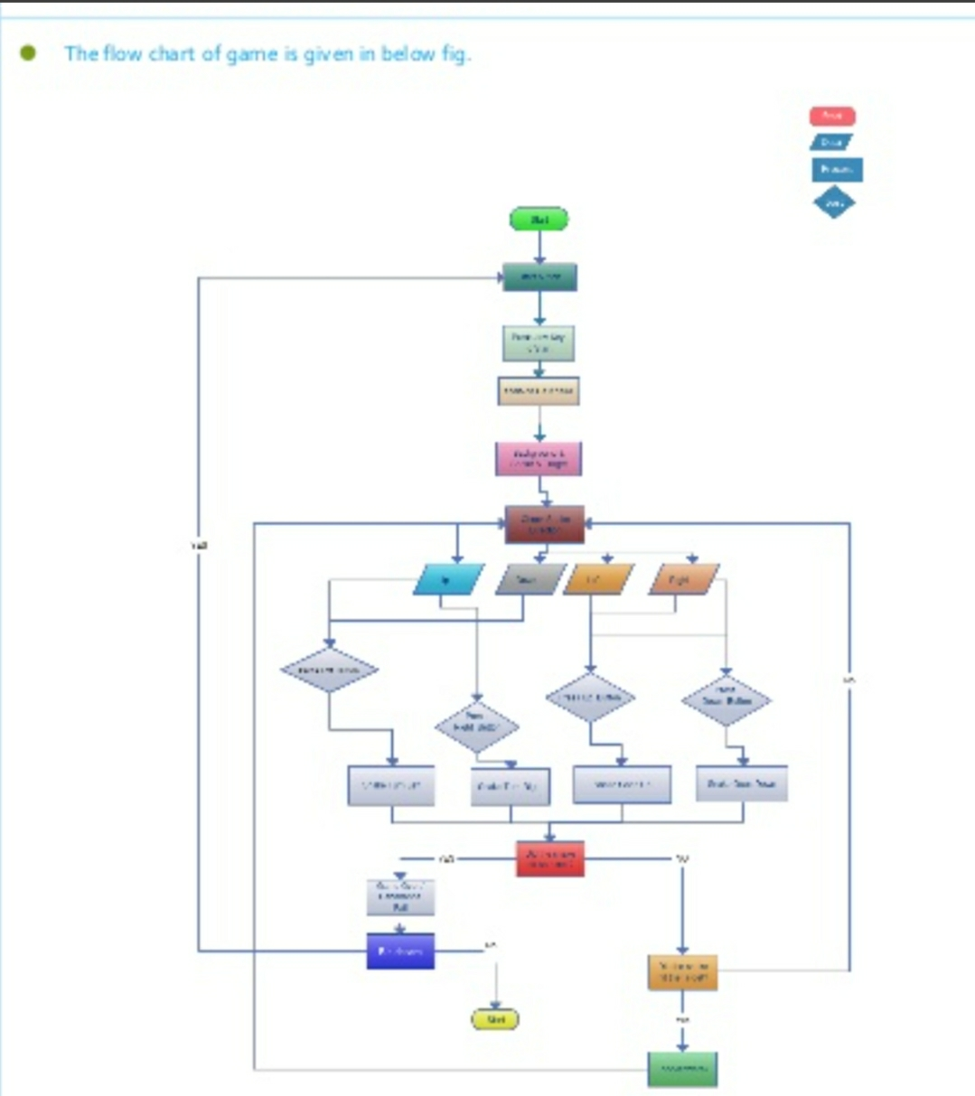

**CHAPTER6**

**IMPLEMENTATION**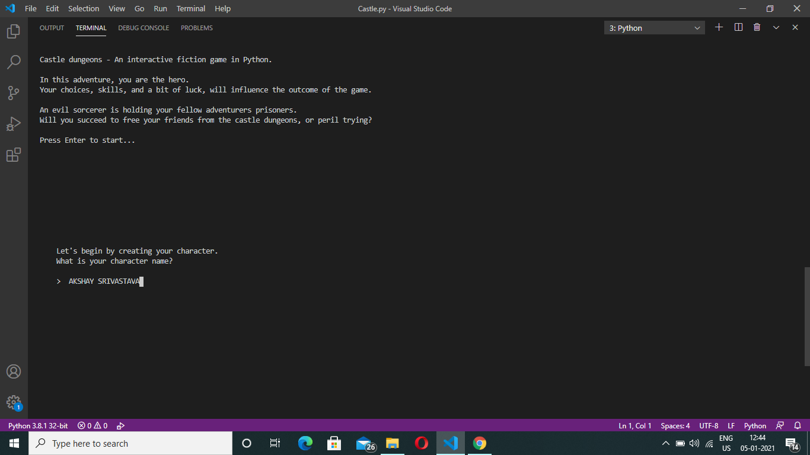

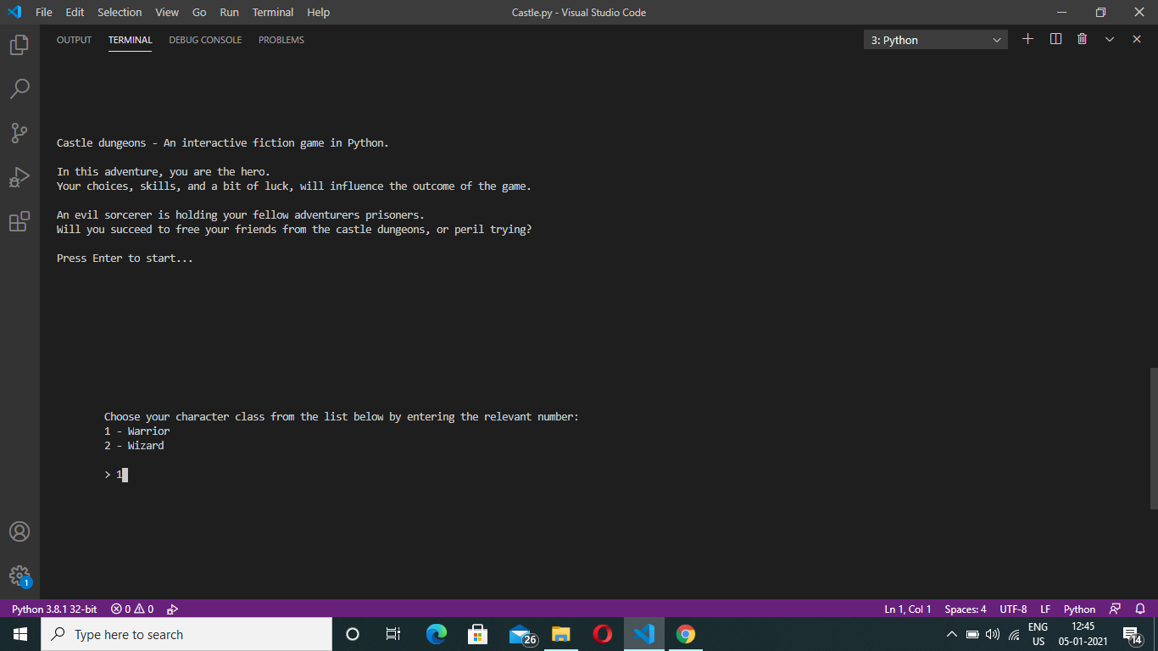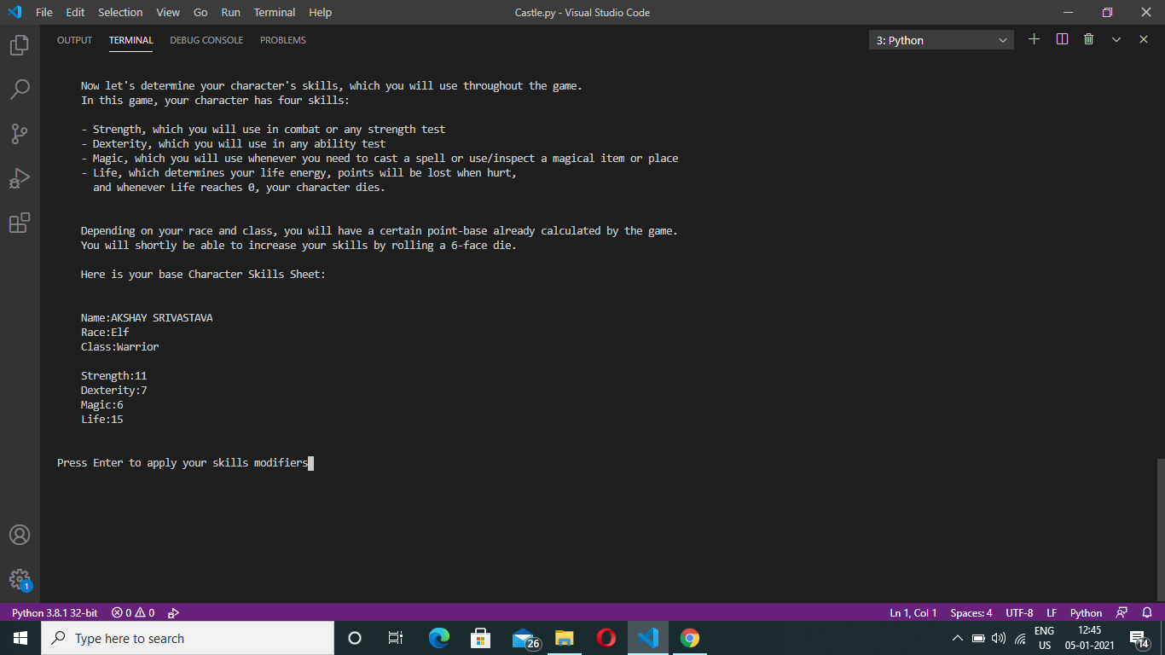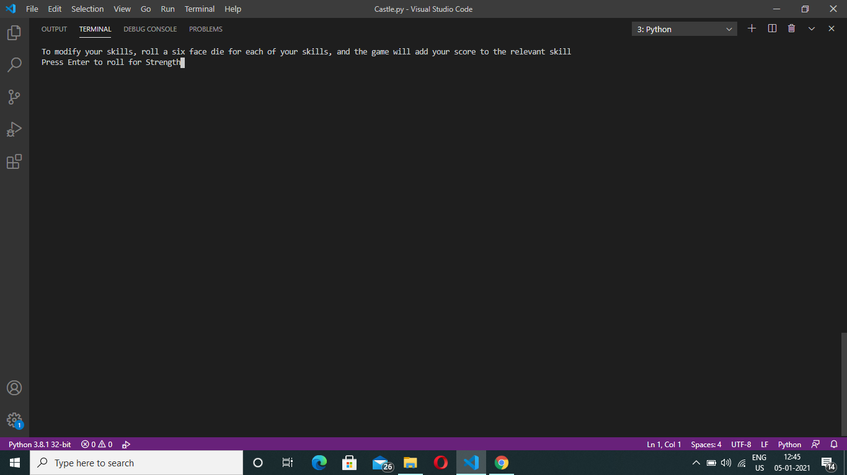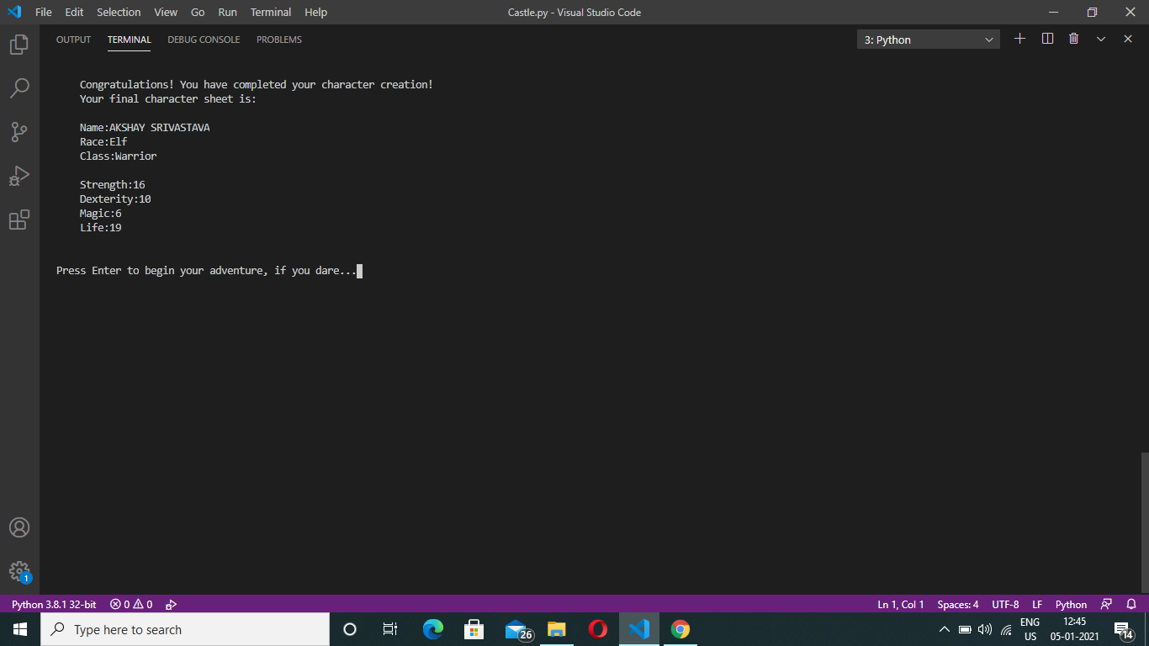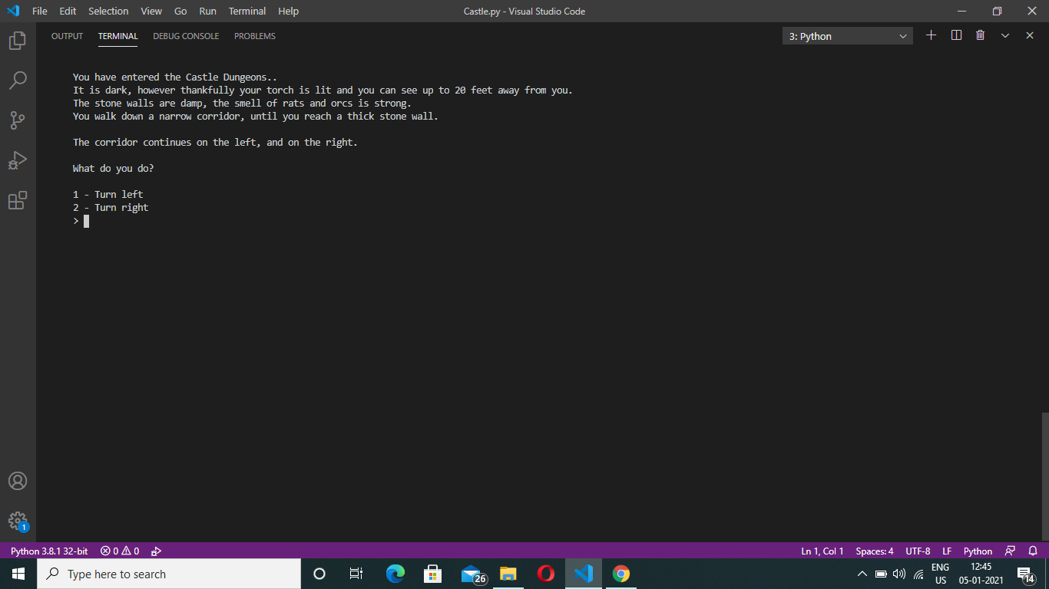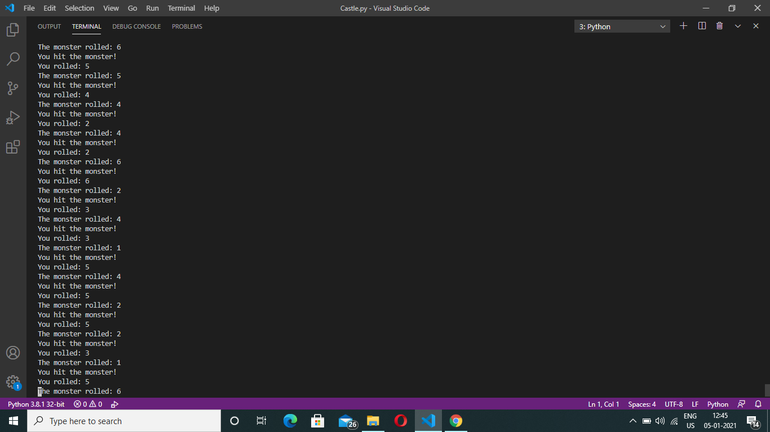

**CHAPTER 8**

**CONCLUSION, LIMITATION AND FUTURE SCOPE**

Python and Pygame is a good language and framework for rapid game prototyping or for beginners learning how to make simple games. Ultimately the performance of Python isn't good enough for the performance intensive parts of the game engine for higher end games. Your export options may be limited to devices with a python interpreter however, which basically excludes mobile.

Python is also good for building tools for game designers which simplify tasks like level design or dialog tree creation and having those tools export that work into a format the main game engine can use.

Some game engines might use Python as a scripting language. For instance I know all the AI behaviors in The Sims games are scripted in Python.

3D Editing Packages like Maya use Python for scripting and it's pretty much a required skill to be really competent with those tools.

Python's powerful string manipulation, large set of easy libraries, and easy shell access makes it an extremely useful language for quickly automating repetitive tasks. (Like resizing 500 textures in a batch)

To sum up, Python is not really the best language for programming games; but it is a very important tool in a game programmers tool kit.